NOTICE: This payment guidance is ONLY for participants from all countries except China.

- Sign in
http://polymer.zju.edu.cn/cesb2015/index.php?m=Page&a=index&id=25
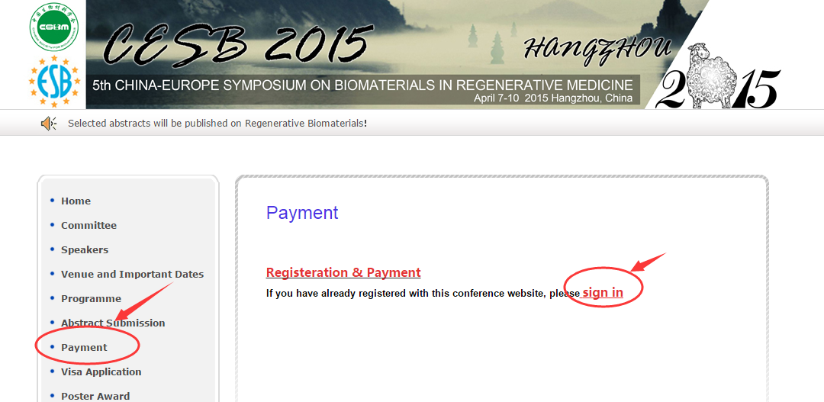

Enter your email and password:
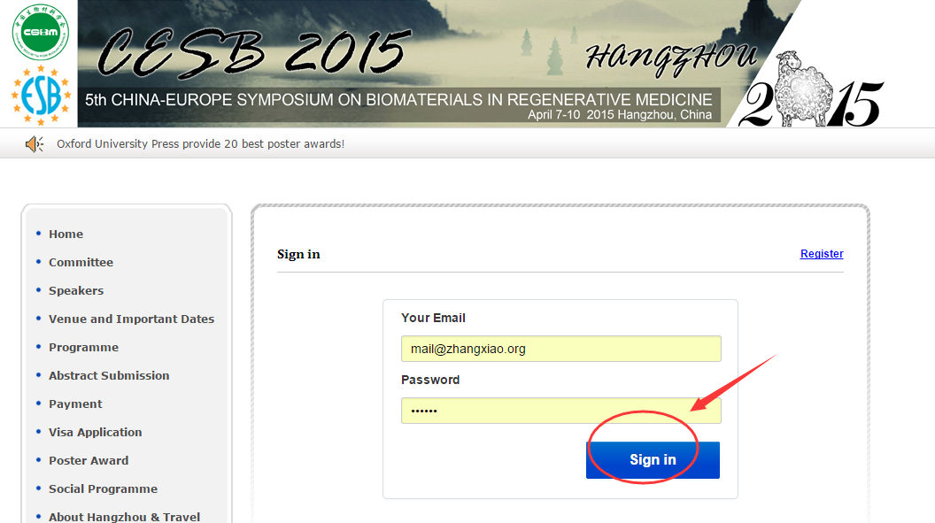

- Payment online
Click the “Payment online” on the left, and select your identity to continue.

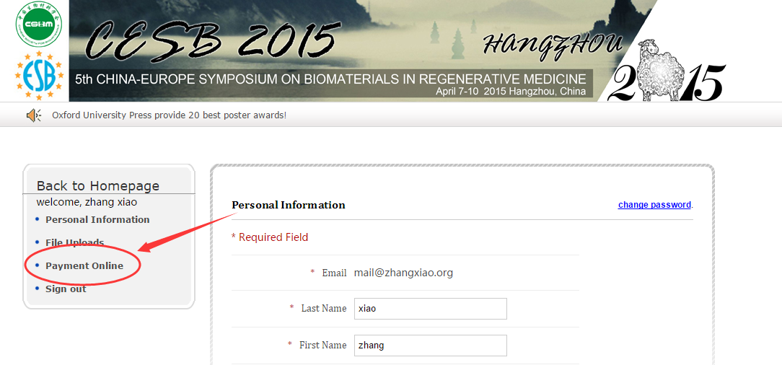

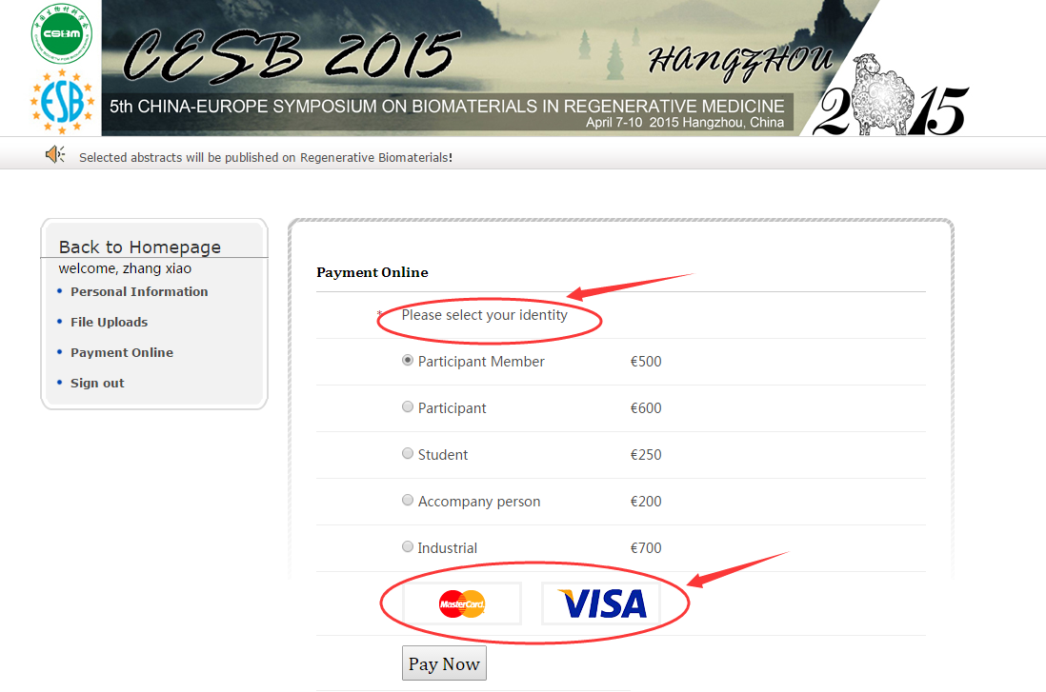
NOTE: In this step, please choose the correct type of payment you would like to make.

Then select the credit card and click “Pay Now” to continue.
NOTE: You can change the language into English by clicking the button on the top right corner.

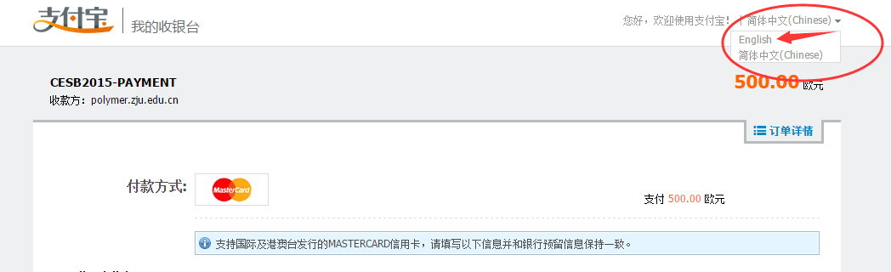
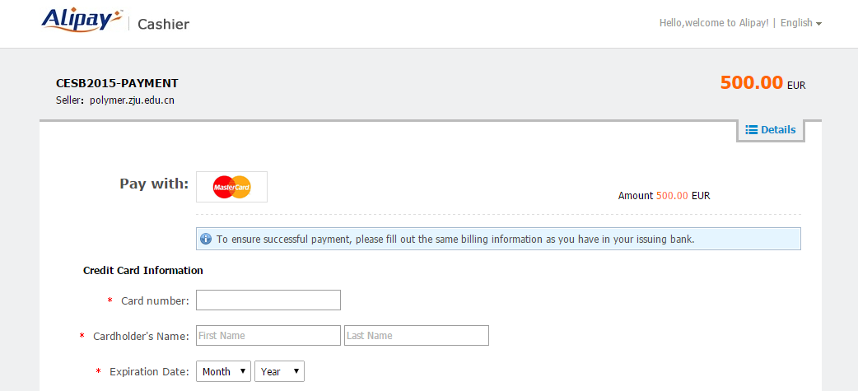
Enter the necessary information.
ALL * Required Field must be filled.

Finished.

